รายงานการรับคณะ Rikkyo University
ณ สำนักงานมูลนิธิแม่ฟ้าหลวง ในพระบรมราชูปถัมภ์
วันพุธที่ 16 ธันวาคม 2563
- ข้อมูลคณะ
ที่มาและความสำคัญ | - อาจารย์ Ayano Nishihara จาก Rikkyo University สนใจให้นักศึกษานานาชาติเรียนได้เรียนรู้เกี่ยวกับธุรกิจกับสังคม/ชุมชน เน้นในประเด็น 1) CSR และ CSV 2) Ethical shift 3) Social and Innovation ซึ่งเป็นหนึ่งในหลักสูตรระดับปริญญาตรี และได้รับการแนะนำจาก Prof. Nonaka คุณฮิเดกิ และคุณพิมพรรณ ดิศกุล ณ อยุธยา ให้ติดต่อส่วนงานมหาวิทยาลัยที่มีชีวิต เพื่อสอบถามรายละเอียดเพิ่มเติม  - Ayano Nishihara เป็นหนึ่งในบรรณาธิการหนังสือ Knowledge Creation in Community Development: Institutional Change in Southeast Asia and Japan ซึ่งในหนังสือมี case study เกี่ยวกับนวุติที่คุณพิมพรรรณ ดิศกุล ณ อยุธยาเขียน
วัตถุประสงค์ | - สร้างความเข้าใจเกี่ยวกับการดำเนินธุรกิจที่คำนึงถึงการสร้างผลกระทบทางสังคม  - สร้างความเข้าใจเกี่ยวกีบการดำเนินธุรกิจของดอยตุง ซึ่งเป็นตัวอย่างของการดำเนินธุรกิจที่มีนวัตกรรมทางสังคมที่ประสบความสำเร็จ
ระดับ | ระดับความสำคัญของคณะ: 5 เป็นหน่วยงานภาคีที่เคยทำงานร่วมกัน  ระดับเนื้อหา: 2 ทราบและเข้าใจข้อมูลงานพัฒนาที่เกี่ยวกับเรื่องธุรกิจเพื่อสังคมและชุมชน  คะแนนรวม 7 คะแนน
องค์ประกอบคณะ | นักศึกษานานาชาติชั้นปีที่ 2 - 4 ระดับปริญญาตรี ของ Rikkyo University และอาจารย์ จำนวน 52 คน
เจ้าหน้าที่รับคณะ | - ผู้บรรยาย นางสาวสลักจิต มั่นธรรมรักษา ประธานสายบริหารงานพัฒนา  - ผู้ประสานงานของมูลนิธิฯ นางสาวณัชวรรัศ ขันติสิทธิ์  - ผู้สนับสนุนการรับคณะ นางสาวอรุณี คงสันทัด
แหล่งสนับสนุนงบประมาณ | หน่วยงานสนับสนุนค่าใช้จ่ายคณะทั้งหมด  รหัสงาน 916-264-101
หมายเหตุ | จัดการบรรยายผ่านโปรแกรม Zoom

- กำหนดการคณะ
ดำเนินกิจกรรมหลักสูตรผ่านโปรแกรม Zoom ตั้งแต่เวลา 11.15 - 13.20 น. โดยแบ่งช่วงการเรียนการสอนออกเป็น 3 ช่วง
11.15 - 11.25 น. นักเรียนเริ่ม sign in class
11.25 - 12.50 น. บรรยายโดยนางสาวสลักจิต มั่นธรรมรักษา
12.50 - 13.10 น. ประเด็นถาม - ตอบ

- ประเด็นถามตอบ

ลำดับ | คำถาม - คำตอบ
1. | Why and how the people (and the guest speaker) started to get involved in Doi Tung project and MFLF?  The Doi Tung Development Project started by the Princess Mother who aimed to reforest Doi Tung. The reforestation effort come along with many initiatives including education development, job opportunities and environment preservation. Beside the Princess Mother, there is Khun Chai, who mobilize the resources and gather all the department to work together such as government, private sectors and community in order to implement the project to be success.  For the speaker, Joy is interested in the development work since she studied in high school and the university. She said, if she could help people to have a better place and better life, it would be meaningful for her. She also loves the way of the MFLF works which is believing in human potential. The foundation’s work can provide a tangible result for the people and the community. Every day of her working life really transforms the people in Doi Tung area.
2. | What is the biggest driver for the people (and the guest speaker) involved in Doi Tung project and MFLF to decide to change the world?  The biggest driver would be “It can be done” attitude. Actually, the MFLF is not going to change the world but we have a strong attitude to make a community to be a better place by starting from a small thing like a ripple effect; from Doi Tung area and expanding to other part of the world.
3. | What was the most difficult experience, and how the people overcame it?  The most difficult experience is about “trust building”. Throughout the working process, we need to build trust as our priority when we do the development work in the community which usually takes time. We need to show the people the tangible result in the short period of time in order for them to believe that we would really like to uplift their livelihood. However, the commitment is the thing that we overcame. We committed to work together in long term to create changes in the area.
4. | How did the Doi Tung project change the way of thinking and doing of the local people who used to grow opium?  We started from the mind set which is “no one wants to be bad but they do not have opportunity to do good” so we provided options to live life for the people. Since we worked with the people who grow opium poppy, we needed to understand them first and try to continually change them through livelihood options. “Help them to help themselves” is our philosophy. Additionally, we believe everyone need to stand for themself first for the development and then we will provide them what they want such as know-how, materials, etc.
5. | Why did you choose coffee and macadamia nuts, and not the other products?  We promote Arabica coffee and macadamia nut to Doi Tung because of the geographical suitability. Doi Tung area at 800 meters above of the sea level has suitable climate. More than that, they have potential for the high values and job creation along the value chain of processing.
6. | What is the biggest issue you are confronting right now? (besides Covid-19)  Adaptation to technology is the first biggest issue besides Covid-19. We think that we are not cope well with the technology compare with the world that is changing very fast nowadays. We will set it as our priority. Another issue is the old generation are getting older and the young generation would not be interested in continue their jobs. The MFLF’s challenge is how to find other options for the young generation to get engage in the project to ensure that the sustainable development will continue in the area.
7. | What are the impacts (positive and negative) from the spread of Covid-19?  We separate impact into 2 types; on the business side and on the community side  Impact on the business: the negative impact is the loss of sales and revenue especially on our tourism unit because we faced lock down condition both domestic and international. Not only on the tourism unit, it also affected on the handicraft unit as well. People try to cut down the luxury expenses which effect on our revenue. However, the positive impact is our time to speed up the e-commerce initiative which is the only channel to sell our product during this hard time and we made it happen already. Additionally, it reminds us to rethink of the industry that we engage with. Business that is too dependent on tourists need to be more agile and more feasible.  Impact on the development (community): the negative impact is on the community itself. For example, after Covid-19 situation, they came back to the community, likely to loss their job or income decreasing. The positive impact on the community is to make the people start reflecting on the resilience against external shock. To think that if similar things like this happen again what they need to do. It makes them think about other opportunity, other sources of income to increase the immunity.
8. | What is the Doi Tung project and MFLF plan to do in the future?  We want to be a business that make the world a better place. By doing that, we focus on the valuable groups such as older people. We have to make sure their well-being is being taken care of and their job security will be provided. Not only focusing on the aging society, we also think of the younger people as well. Since the world is changing very fast. The kids need skills and tools to survive in the outside world. Other social problem that might happen and we think it is our priority to work with is drug related problem in the younger group. Since Doi Tung area located along the border so we need to empower the younger people to avoid drug usage.  Additionally, we want to be a successful model on sustainable development, reforestation, social entrepreneurship and addressing climate change.
9. | Doi Tung coffee is sold at Kaldi and in Ibaraki prefecture. How did it start, and what are the future plans?  It started around 12-13 years ago. Kaldi has a Thai partner and they were interested in Doi Tung. The Thai partner asked the CEO of the Kaldi to visit Doi Tung. On that first visit we learned about Kaldi business and Kaldi learned about our social mission. MFLF and Kaldi have the same value on the sustainable development on how to help people to help themselves. From the first visit in Doi Tung, Kaldi did not buy our coffee since the quality was not meet their standard. However, it really pushed us to improve and develop our coffee plantation management process to meet their standard and many years later, our DoiTung coffee was bought by Kaldi. At present, we sell our coffee to Kaldi around 15 tons/year.  In Ibaraki prefecture, we have 2 branched of Café DT. One is at the Josai hospital and another one is near the train station. We started the project with Josai hospital 13 years ago. They donated medical equipment to the people and trained the medical team in the remote area. From that cooperation, The Josai hospital doctor wanted us to open the DoiTung Café at the hospital.  Future plan, is to strengthen the relationship. Since Kaldi is a global sourcing company, we need to develop not only DoiTung products but also those from our extension projects for better quality and sell more to Kaldi.

- Lesson learned
- 19% have learned the concept of 3S model is an important model for development towards sustainability
- 13% have learned on setting business goal need long tern perspective and aware of social responsibility
- 11% emphasized on giving opportunities for people is important as the Princess Mother said “No one wants to be bad, but they do not have opportunity to do good”
- 10% have learned the important key for the development is trust building and commitment
- 8% have learned on giving education for young people so they will have skill and knowledge as future leaders for sustainable activities
- 6% have learned on improving working environment can solve social problems
- 4% have learned on believing in human capability to change and about vicious cycle
Student No. | Lesson learned from the students
1. | I was impressed by the phrase "No one wants to be bad but they do not have the opportunity to be good" "Help people to help themselves". In Japan, it might be easier to have good life, but in other counties it might be difficult just because of their opportunity. We should do more action to make them have a lot of opportunities to be good. We should believe in human capability to change. The origin of everything is human. If we change, everything can be changed to both good way and bad way.
2. | What I learned from the previous session as the most important lesson is about Doi Tung Development Project. I was impressed by the project that helps people lived in poverty without basic infrastructure or government supports. I learned that it is the most important key to build a relationship of trust with local people to improve the life of local people. In addition, 30 years after the project, Doi Tung Development Project actually successes and becomes sustainable development project. I was impressed by the appearance of efforts and implement.
3 | I was able to realize that various companies around the world are doing various things to realize a sustainable world. In particular, in this class, I learned about Thai companies that are also related to Kaldi and IKEA, so I thought that various companies are really involved in SDGs.
4. | I thought it is very important to solve a problem by finding the strength inside and making use of it as a core element of the solution.
5. | I thought most important and impressive sentence in the presentation was "Collaboration is a fast way to learn". In previous class, professor was talking about interdependent, not independent. I think it is really related to case of Doi Tung. They are trying to collaborate and survive together with others. That's why they could make the village better.
6. | Whatever to start new things, the most important thing is making the trust relationships and spend the same times. All people have opportunities to live equally regardless pf race, religion or nationality!!
7. | Through the lectures in this class, I learned the importance of looking at things again. This is because we need to approach it from a different perspective in order to do business or to produce something that no one expected. I will want to change my perspective and think about things and eventually business.
8. | The most important lesson from guest speaker’s lecture is that giving opportunity to do good is necessary. I thought this way of thinking was important. Some people don’t have know-how and it becomes reason of falling into poverty, so I thought support system such as Doi Tung development project is effective for them.
9. | The most impressive take-away from this lesson is that people are the most important thing, and it is crucial to give them the skills to be proud of themselves and to be able to live on their own. I am also impressed by the words of the princess mother, "no one wants to be bad, but they do not have the opportunity to do good". That is true and it is clear that we should help people to help themselves by giving such opportunity. Nevertheless, there are many times when we try to help people in the wrong way. While it is important to focus on the economy and society, I felt that we need to keep the awareness of taking care of people first.
10. | With the current media always showing and talking about the world getting worse, and that people are causing deforestation, I was genuinely very surprised to see so many trees growing in the past years. As it is true that some things have been declining, but hearing today’s guest speaker made me feel more hopeful about the world’s future. I believe that it is not right to say people should “save” or "help maintain" nature, because that puts human beings in a higher hierarchy than nature, I really like the way the guest speaker phrased that the company’s goal is to “empower people to coexist with nature”, putting people and nature on the same level.
11. | The most important lesson I learned from the class is that the development and problem-solving of developing countries requires the support of someone who has power such as companies and the reform of citizens' consciousness. When I saw the green revival in the photos before and after the Doi Tung project, I felt really good. I thought that corporate support would create employment, which would lead to the development of the country again.
12. | The most important lesson take-away from today's lesson is that the purpose of Doi Tung project is to leave from vicious circle by changing narcotic cultivation to coffee cultivation. Before the project was born, people in Thailand and Myanmar had lived by cultivating narcotic. Because of poverty, in that area, there are issues of lacking knowledge, epidemic of aids and prostitution.
13. | The most important thing learned from today's lesson is the developing company has faced to poor quality labor environment. A lot of companies have outsourced non-core tasks to these countries such as Thailand, Philippines and Vietnam because there is low cost. Therefore, they are forced to work poor environment, meanwhile they can get new job.
14. | I felt that creating the ecosystem is way more effective than helping money and stuff in case of promoting poor countries to be independent. Because sending money and stuff only help transiently. Once it’s done, people will be back to just wait for help. We can’t expect any growth if we continue it. Therefore, it’s so important to educate people about skills and knowledge, and take sufficient care to do so. It takes long, but it does help eternally.
15. | The most important lesson in SS12 is that improving or making working environment can solve social problems like poverty, unemployment and modern slavery. I learned coffee industry has many problems; modern slavery, unfair-trade, child labor. However, many people do not know or realize these problems. Many companies are trying to solve social problems not only making a profit, and we should know or realize the background for social problems and manufacturing process.
16. | The most important lesson I learned from today's lesson is “3S model”. I can learn from a lot of classes, “sustainability is important” and “we have to toward sustainability “. However, I think I can't really learn how I'm working on sustainability. Therefore, it was really valuable time. Thank you so much for your presentation, Ms Joy.
17. | The most important lesson I learned from today's guest speaker session is that the key, main factor for making social innovation is people not society and environment. Of course, society and environment are key factors but people who have passion are the most important. And also, I think Doi Tong project is the most successful example of social innovation I have ever heard. The project produced huge benefit and raised people wage and I was surprised when I saw pictures of restoring forest. I thought COVID-19 have only negative impact on thin project, however according to speaker, she said it has both of positive and negative impact in terms of two aspects business and community.
18. | In this session, I learned how wide Doi Tung Development Project influences the local people in Thailand by offering scholarships to the students and preparing for job opportunities.
19. | Not only is Doi Tung doing business for some purpose, but in addition to that, taking into account the current trend of SDGs, they are cherishing the environment. And what more surprising me is that not only to improve the present, but also for the future, they are also making efforts to develop new leaders
20. | I leaned 3S Model which are survival, sufficiency and sustainability. In japan, we have survival and sufficiency, so we can focus on sustainability. But I found the other developing countries do not have these because their infrastructures are not enough. And that is why they cannot go to the sustainability phase. Therefore, I thought developed countries such as japan have to be more conscious about sustainability for other countries.
21. | The most important lesson that I learned from the lecture by the guest speaker is how they have shifted their business and adapted to the COVID-19 situation. It is also impressive how they are producing products such as coffee beans and so on with lots of care for the environment. In the future, I would like to use and share what I learned from her.
22. | In general, making profits is seen as the main objective of any business, but Doi Tung development project aiming enhancing local wellbeing. Those projects not only created communities, but also are offering new learning technologies and activities.
23. | The most important lesson that I learned from today’s lesson is that working with thinking about the society is very important for companies. I thought that companies should think about the benefit first before. However, I began to think that companies should think about both benefit and the society. Therefore, I want to work for the society in the future.
24. | I was able to understand the structure of the coffee industry. We also learned about the structure of coffee companies in Thailand.
25. | The most important take-away from the guest speaker’s session was that thinking from a different angle changes the situation. For example, they turned the negative situation that making a living by drugs into a positive situation in which people can make money and feel happy. Also, the whole story made me again realized how sustainability is important to society. I thought considering a series of the issues we have helps to change the situation a lot.
26. | I was taught a vicious cycle. There are three points which are sickness, poverty, and ignorance. Poverty leads to a lack of many opportunities. For example, sickness is malnutrition, Malaria/TB, HIV, and drug addiction. Ignorance is a weak social structure's inability to develop. Poverty is opium cultivation, migration, prostitution, deforestation, and desertification. 3S Model is a development model towards sustainability. 3S means survival, sufficiency, and sustainability. Access to basic healthcare is needed for survival. The basic value that adds processing facilities is needed for sufficiency. Socially and environmentally responsible works are needed for sustainability. I can find a foreign company in Thailand that is active in CSR project activities.
27. | In the session, 3S model which is a development model towards sustainability was the most important lesson learned for me. Since I had never heard the unique model before, it was very impressive, also it clearly showed us what kinds of treatment lead to sustainability. Thus, this model is good for companies which they are not sure how to measure their efforts for sustainability. I guess that most of companies take a long time to achieve all of these three sections, because reducing expense or reviving nature resources is not a short-term goal. However, if the number of companies which engage with the model is increasing, this world situation will be better.
28. | It was very interesting from the perspective of revitalizing the Thai town. I thought it was really amazing to be able to revitalize the town so far using one product. I don't think of such cases in Japan so much, so I was impressed by the fact that I brought them so far.
29. | This session we learned about the Doi Tung Project from Ms. Joy, and I had never heard of the project before, so it was very interesting to hear about The Doi Tung Development Project and how it is focused on the area of Doi Tung and has infused life into a previously moribund economy.
30. | I was impressed the project which she did with coffee. Also, I have never heard 3S model which is development model towards sustainability, so that was the most important lesson for me in last session. I thought many people may doesn’t know the 3S, so we should know and learn about it more, and to spread is really important for future.
31. | The most impressive lesson from the session is that trust building with local people is the most difficult and necessary when she takes part in the projects first. So, they had some meetings to listening to the locals ahead of the projects and worked with local representatives, then learns by doing by their hands. Those kind of communication helps them to build strong relationships with local people. Thus, I understood that when it comes to set up a project especially with local people, it needs to communicate with them and ask for their help.
32. | Until now, I knew only the name of CIRCULAR ECONOMY, but I didn't know what it meant. However, I was able to understand in detail through this lecture. In addition, it was helpful to understand concretely how SDGS is actually used in business. From now on, I would like to support companies that are fulfilling their social responsibilities.
33. | The most important lesson I learned today is that the 3S model is an important model for development towards sustainability. The first one is survival, which access to basic healthcare. The second one is sufficiency which basic value add processing facilities. And the third one is sustainability which is important for both socially and environmentally.
34. | I learned about the case in Doi Tung in this lesson. By spending 30 years, the situation in Doi Tung has been changed. She said that there is 3S model which is steps for realizing sustainable development, survival, sufficiency and sustainability. I thought that this 3S model shows clearly what is needed. One of the actions is a farming coffee and macadamia nuts, and it leads indirectly to develop the city for tourist and handcraft industry. Finally, Doi Tung is aiming to create a circular economy. It cannot be done by every country, so I hope for its success.
35. | Thank you for the inspirational question. I agree des that we don’t necessary change while world; we have to commit to the area where we can contribute towards. In your business, you do contribute to the specific area and trying to realize growth, improvements and SDGs. I totally agreed and support your idea that we should do what we can, not we should do something which surpasses our ability.
36. | What I learned today is that to succeed social innovation, visiting the area, communication with local people and understanding the area is essential. I wasn't sure why the foundation chose coffee and macadamia, but it is because these are appropriate crops for Doi Tung. And also, Joy san said "Collaboration is a fast way to learn" in the presentation. In my opinion, to collaborate with someone, it should both of them can receive merit. Therefore, to understand strength or resource is very important. From this, today I learned well understanding of the area is very important for "yoso-mono".
37. | The most important lesson I learned from today’s session was that not offering products or cash but offering opportunity to be good is necessary to change the situation and to accomplish next generation’s happiness. 3S model is good idea because it is difficult for poor people who only handle today’s life to accomplish final goal like sustainable society. By setting step for final goal, it becomes clear how to change their life and environment and that motivate people to accomplish good life in the future.
38. | It was interesting learning about the DoiTung development project because it showed the people who are experiencing poverty or are from third world countries do have the chance of becoming developed through better health care and utilizing the assets of that country. In Doi Tung's project, it was the agricultural assets that helped shaped the province of Thailand to a better more livable one. Businesses should take on that bet that a country could supply income or become a whole business with a little help, to differentiate one business to another.
39. | The most important thing I think from this lecture is that the fundamental goal of business and human being is happiness, so we always seek to get happiness from several approaches. For example, as for the business, we try hard to earn money but it is not for money but for our happiness or wealth. As for the SDGs, it looks like company should try to have good image but it will actually become someone's happiness. I think this way of thinking is very good since I also feel happy to imagine about someone's happiness.
40. | I think 3S model is the most important. 3S model (Survival, Sufficiency, Sustainability) is very difficult goal. It is because, we must win Survival and maintain Sufficiency and Sustainability. I also learned business relate small social area. Doi Tung’s business solve social problem and make profit. In this way, make profit and solve problem is really 3S model. I think it circulation is very important.
41. | What I thought was most important in today's class was how to set business goals from DTDP (Doi Tung Development Project), I felt that the purpose of the business was not just immediate profits. From the word “business with a heart” of DTDP, the business purpose must be meaningful to society and people. By doing so, you can carry out a business that is familiar to many people.
42. | Today I took a guest speaker class from Ms.Joy, Doi Tung Project. From today's lesson, I learned importance of sustainability again. Doi Tung project was established in Thailand in 1989 with the aim of eradicating drug. Not only that, I found it wonderful that the project was also self-sufficient and able to prevent poverty.
43. | The most important thing that I learned from today's class was the importance of deciding the goal of business. I felt it was not enough to just pursue money in business. In other words, the business should be a hero for people and society who makes them happy. I thought the real business is to pursue it through today's lesson
44. | What I thought was most important in today's lecture was the importance of goal setting in corporate management. From today's guest lecture, I learned that it is essential to have a long-term perspective when setting goals for corporate management. For example, from the DTDP project, we learned that the objectives of each business cannot be based on short-term goals. In addition to making a profit for the company, it must also lead to the benefit of society as a whole. By achieving both of these goals, the management of the company will be supported by many people, and ultimately, the company will be able to achieve its long-term goals.
45. | What I learned from this guest lecture session as the most impression thing is seven goals among the SDG's. In this part, she mentioned "Balanced", "Human rights", "Leave no one behind", "Measurable outcomes", "Continuity", "Holistic and integrated" and "People-centered". as seven things. Particularly, I was interested in "people-centered" because it is needed the power which engage them and involve them something like that.
46. | The most important thing in today's class is setting the mission. I realized that listening to the mission would guide our actions. I feel that the Doi Tung Development Project has a positive impact on the environment and society and that it is focusing on developing future leaders. I was able to recognize that it is important to nurture young people who will be responsible for sustainable activities.
47. | Today, what I learned from the lesson is that it is crucial for making our society sustainable to recognize the recent state of society through 3S indicators. In my opinion, we need to understand how we have achieved to make society sustainable to come true it, so that we also need the way to measure. For that, 3S indicators are very helpful. Therefore, I think that we should be used to measure our progress by the indicators.
48. | The most important thing in today's class is setting the mission. It was impressive that the Doi Tung Development Project (DTDP) not only has a positive impact on the environment and society, but also focuses on developing future leaders. I was able to reaffirm that young people are indispensable for conducting sustainable long-term business.
49. | I was impressed that Doi Tung development project can solve poverty and other problems caused by poverty such as drug cultivation, lack of education and prostitution. I have never known about this coffee beans and the project, so I would like to more people get to know about this product.
50. | I learned that the influence of the coronavirus has changed the way we do business. In the future, I felt we needed to learn new ways of doing business. In addition to that, it was also helpful to know information about coffee beans. I also learned that business approaches differ between developing countries and Japan.
51. | The most important lesson I learned is changing the ways to business under the influence of corona virus. Also, in Japan, many companies have been to be forced to go bankrupt and stop to run business. In this situation, they need to think how to deal with the corona vortex. Not only that, we have to remember the difference of the way of business between undeveloped countries and developing countries. Thank you for providing us easy to understand explanation.
52. | In today's class, I learned about sustainable development and the entrepreneurial spirit of society. I had some experience with Doi Tung in the pre-assignment, so I was able to listen with interest. Especially, I was very impressed by "3S Model", because it was my first time to hear it. I felt that the idea that survival is necessary for sustainability is new.

- ข้อเสนอแนะเพิ่มเติม
- I think that this project can be a representative example for not only other developing communities but also developed communities.
- It was little hard to me to understand the content because of lack of listening skill.
- There are few opportunities to hear such valuable stories. I do not know how I could understand your stories because of English problem, but I really appreciate for your presentation.

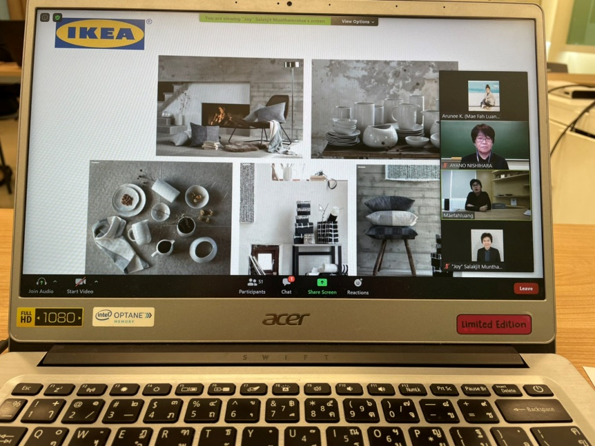
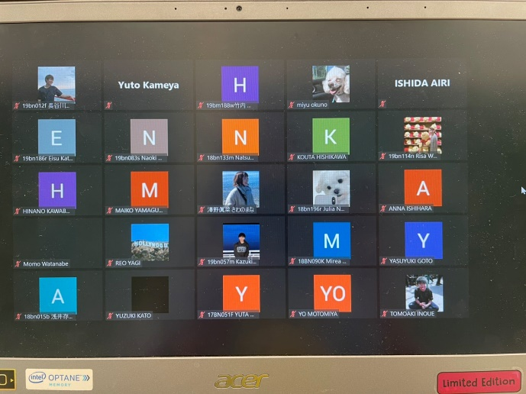
- ภาพประกอบ

ระหว่างการฟังบรรยายภาพรวมโครงการพัฒนาดอยตุงฯ จากนางสาวสลักจิต มั่นธรรมรักษา ประธานสายบริหารงานพัฒนา

