The Study Visit of for the Colombian Delegation
21st – 29th October 2016
Annex III: Optional leisure programmes for the Colombian Delegation
Saturday, 22nd October 2016

Pick up point: | The Cottage Industry Centre and Outlet
Pick up time | 16.00
Mode of transportation | Van (at least 5 people per route)
Remark | - Please confirm your selection by 21st October 2016

Route options:
Route 1: Mae Sai district, Thailand – Myanmar border checkpoint
Distance from the pick up point | 21 km. (30 min drive approx..)
Description  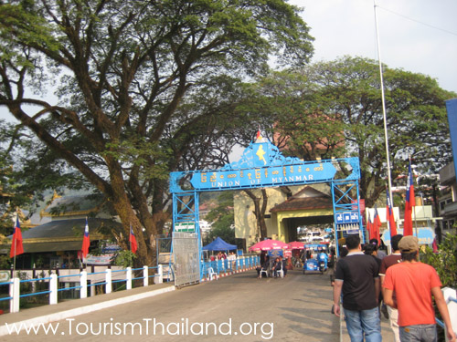 | This Thailand’s north-most district is on Highway no.110. Serving as the border town with a bridge crossing over the Mae Sai River, connected with Myanmar’s Tha Khi Lek, Mae Sai is always busy with people crossing the borders, from locals making trades to tourists passing for traveling trips. There are also choices of tour services to nearby cities, such as Myanmar’s Chiang Tung that is approximately 160 kilometers to the north.  (source: http://www.tourismthailand.org/See-and-Do/Sights-and-Attractions-Detail/Mae-Sai--4421)
What to do | - Shopping  - Border check point (Participants may not be able to cross the border due to the time limitation)  - Local restaurants
Remark | On the way back, it will take 30 min drive from Mae Sai to the Greater Mekong Lodge

Route 2: Chiang Rai night bazar
Distance from the pick up point | 51 km. (60 min drive approx..)
Description  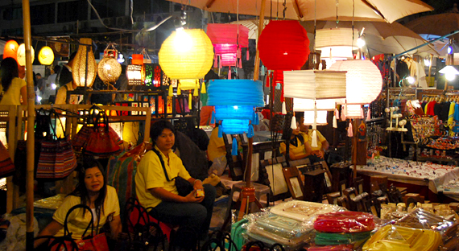 | Chiang Rai Night Bazaar is the center of the Lanna culture and showing a variety of crafts and souvenirs Lanna from Lue, Lowland Thais and hill tribe such as carpets, curtains, scarves, silk, bags, jewelry and the other is a delicate task. Available at reasonable prices.  (source: http://chiangrai.sawadee.com/shopping-where.html )
What to do | - Walking street  - Shopping  - Traditional performance  - Local restaurants
Remark | On the way back, it will take 60 min drive from Mae Sai to the Greater Mekong Lodge

Route 3: The Golden Triangle and Chiang Sean Ancient city
Distance from the pick up point | 40 km. (50 min drive approx..)
Description  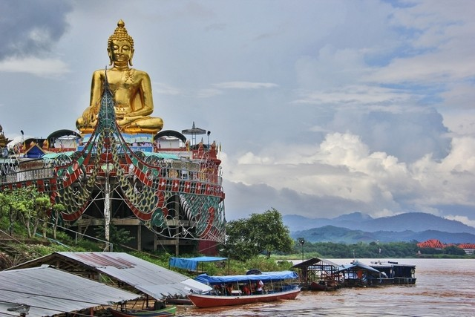 | Visiting the renowned Golden Triangle is a must to complete the trip to Chiang Rai province! This is the famous location where the borders of Thailand, Laos, and Myanmar meet in the middle of the Mekong River. The Golden Triangle was formerly known as the world’s major producer of opium, which was later improved thanks to the works of the Royal Projects. Reaching the Golden Triangle where Thailand, Laos, and Myanmar join is easy as it’s only 9 kilometers north of Chiang Saen, by taking the road parallel to the Mekong River.  (source: http://www.tourismthailand.org/See-and-Do/Sights-and-Attractions-Detail/Golden-Triangle--4418)
What to do | - See the natural border areas (Thailand – Myanmar – Laos)  - Shopping  - Temples  - Local restaurants
Remark | On the way back, it will take 20 min drive from Mae Sai to the Greater Mekong Lodge

