For sustainable growth
Suggestion for new market of Macadamia nuts.
Yusuke Takahashi
Hitotsubashi University Graduate School
Of International Corporate Strategy (ICS)

I thought that finding new market is important for sustainable growth in agriculture field. Therefore, I would like to offer two suggestions of new market, which I would be able to contribute.

1: AEON Group, which is a retail trade of the Japanese second place,
Mr. Horii was in charge of this project. He lives in Thailand and works in Topvalu Thailand. He developed his company’s private bland, TOP VALU. He was interested in CSV business, so he developed two products as TOP VALU.
One is Fair trade Chocolate. Cacao was imported from Dominica with reasonable price (fair trade). The other is fair trade coffee. If the quality and volume of macadamia nuts could be filled with AEON’s request, Doi Tung’s macadamia nuts would be commercialized (other type of nuts would be available)
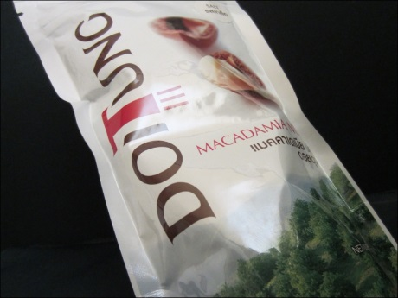
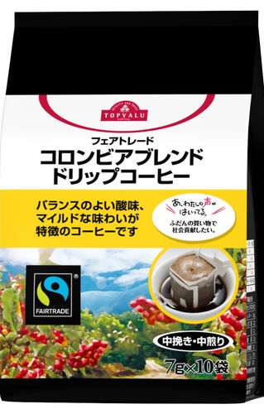
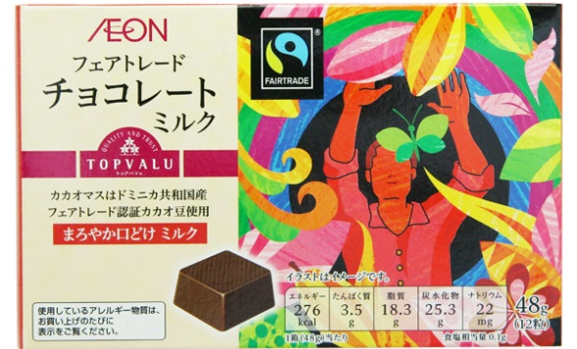

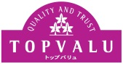

▲Fair trade chocolate ▲coffee ▲Doi Tung macadamia nuts

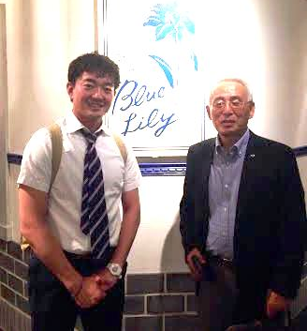
2: Mr. Sato, founder of Kenya Nuts Company http://arkafrica.com/clients/kenya-nut-company
He is very famous for Macadamia nuts trading in Africa. He said he had been to Mae Fah Luang Foundation long time ago for discussing Macadamia nuts trading. But at that time, the quality of nuts was not good so he couldn't buy the foundation's nuts. But if the quality improved, he is also interested in trading. I can introduce him again.
▲Mr. Sato

For sustainable growth
Suggestion for making good composts from Macadamia nuts’ husks.

Yusuke Takahashi
Hitotsubashi University Graduate School
Of International Corporate Strategy (ICS)

I would like to contribute your project by applying my biotechnology background. For example, I would like to try to make good composts from macadamia nuts’ husks, because I know cost of chemical fertilizer is high in Thailand. If farmers could make composts easily and quickly, they don’t need to buy expensive fertilizers. In addition to that, my company has a factory in Kamphaengphet, Thailand. I think this place would be near to Doi Tung. If it is near, I would like to think collaboration with Kamphaengphet factory which has a lot of byproduct as a good fertilizer.
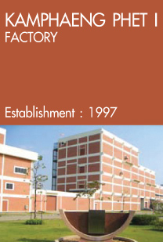
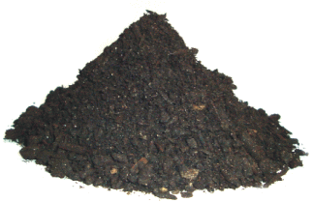

▲compost

▲Ajinomoto Kamphaeng Phet factory

